|  |  |
| --- | --- |
| **Name:** | Molly |
| **Age:** | 3 |
| **Breed:** | Tabby |
| **Size:** | Medium |
| **Colour:** | Black, brown and white |
| **Personality:** | Relaxed and quiet. |
| **Description:** | Molly a very calm cat who enjoys to sit in the sun all day or on a lap by the fire. |

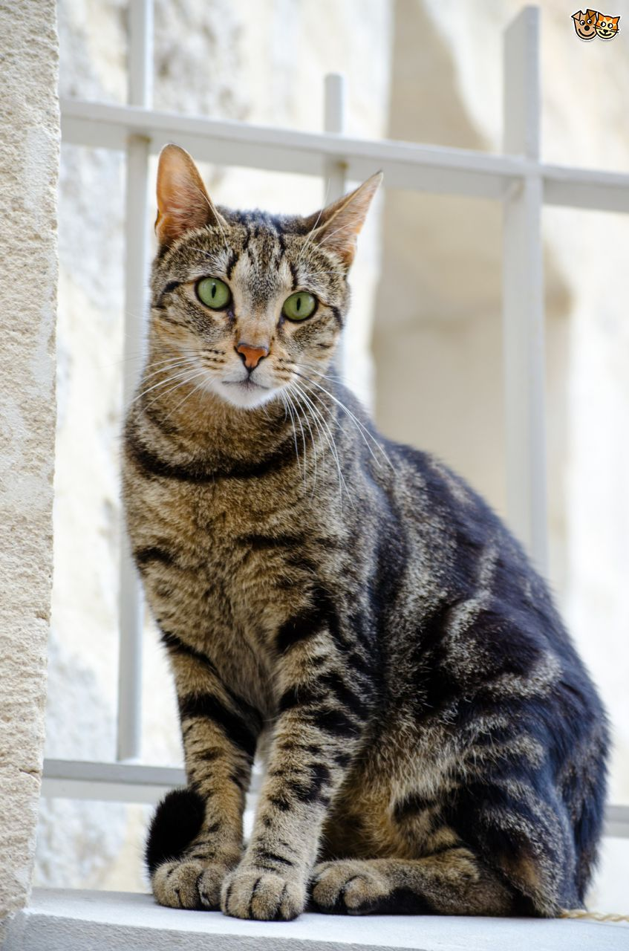

|  |  |
| --- | --- |
| **Name:** | Nelly |
| **Age:** | 2 months |
| **Breed:** | Long haired tabby |
| **Size:** | Small kitten |
| **Colour:** | Black and brown |
| **Personality:** | Timid, curious and playful. |
| **Description:** | Nelly is a very playful cat. She is shy and timid around new people but once she gets to know you she is very comfortable. |

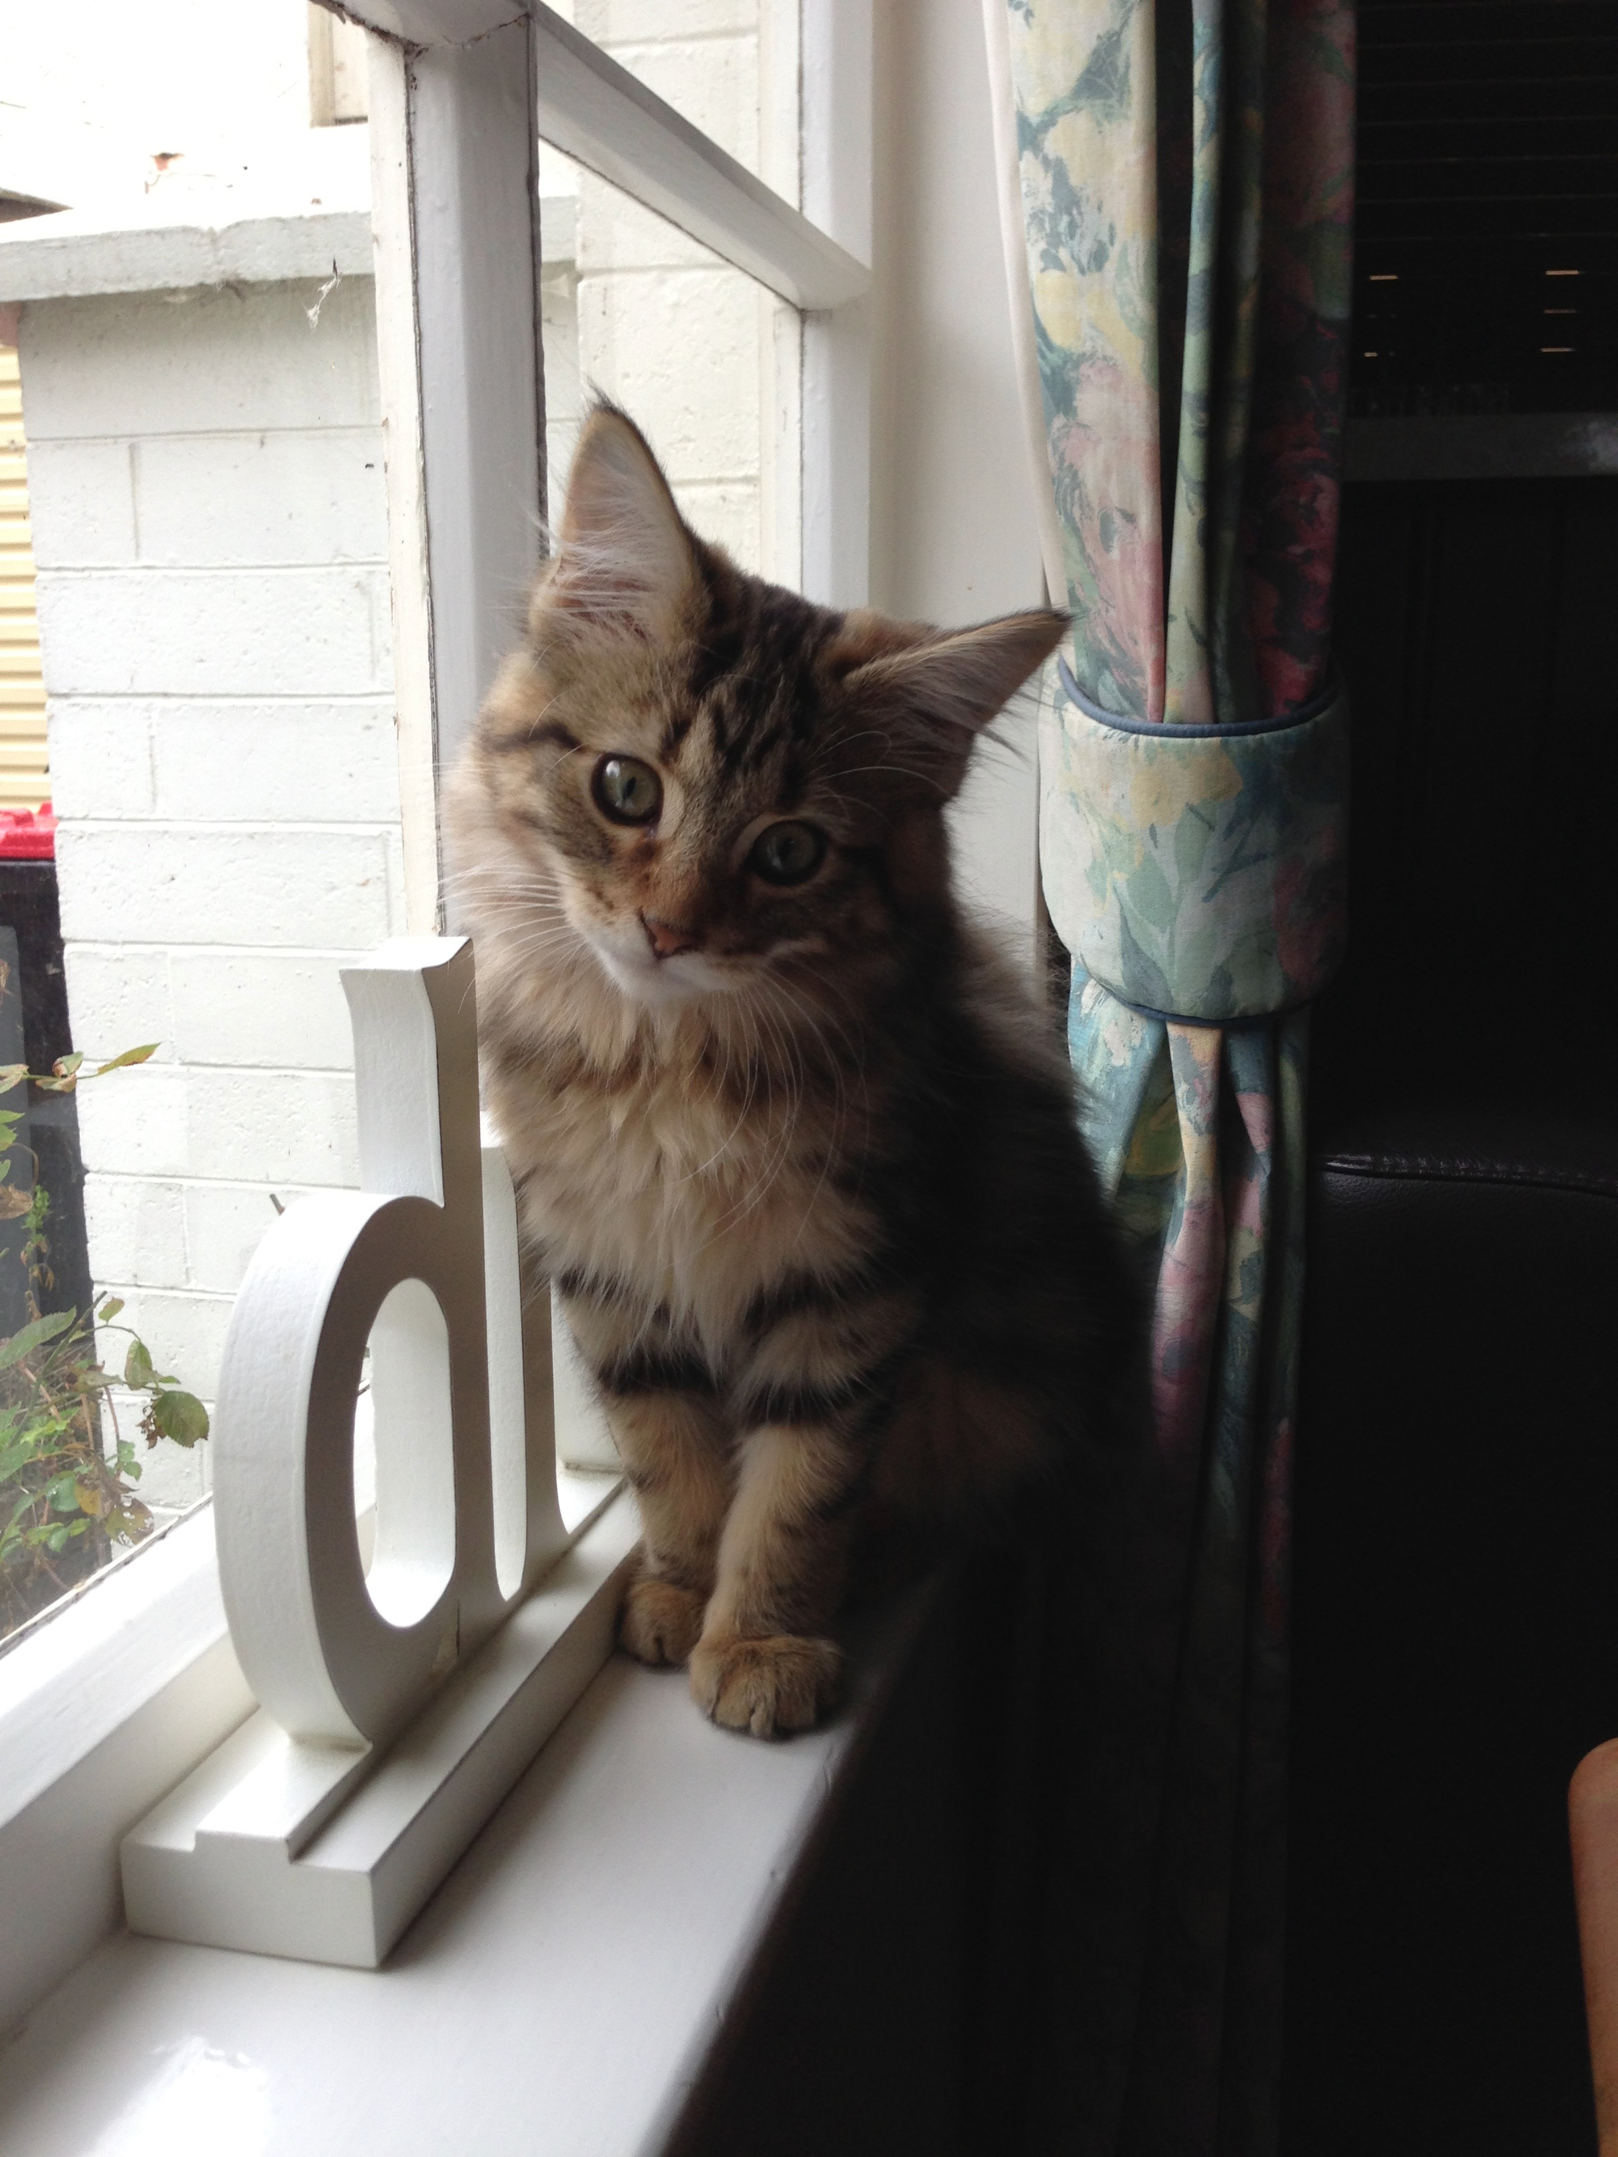

|  |  |
| --- | --- |
| **Name:** | Alex |
| **Age:** | 8 |
| **Breed:** | British Shorthair |
| **Size:** | Fully grown adult |
| **Colour:** | Grey |
| **Personality:** | Quiet and friendly. |
| **Description:** | Alex is a quite friendly cat who enjoys sun bathing! He likes to go outside for short periods and is used to living inside. Alex is looking for a loving new family. |

